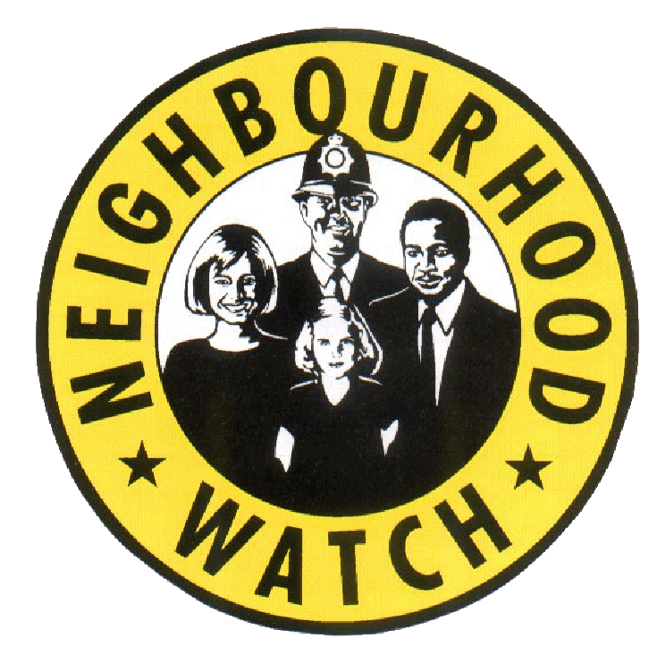

EAST RIDING NEIGHBOURHOOD WATCH

October 2025
Dear Neighbourhood Watch Coordinators
As always, we thank you for the work you do to help reduce the fear of crime. We also welcome all new coordinators who have either set up new groups or taken over existing ones to help keep their neighbours safer.

Please Consider Signing Up For Community Alerts (MCA)

If you are not already signed up to my Community Alert please do consider it as a useful information source for you and your neighbours.

My Community Alert is a free messaging system operated by Humberside Police, Humberside Fire & Rescue Service, and Humberside Office of the Police & Crime Commissioner, giving you live information about incidents happening in your area. As well as a chance to share opinions. You can also register your CCTV and Video Doorbells.

Recent alerts have covered seasonal and local crime issues and updates from your policing teams, police surgery dates, new police innitiatives, Fraudwatch alerts and general security advice.

Some of items you are missing out on incude…

- Access to a monthly newsletter with crime prevention updates and information.
- Invitations to Webinars to raise your awareness of crime tactics and raise your resilience to them
- Opportunities to give your feedback and suggestions on shaping local policing
- Invitations to be part of police led Webinars
- ‘Mini Police’ innitiatives and activities that children can get involved in.
- Police operation updates (operation yellowfin for example targets reckless and anti-social use of motorcycles, e-bikes and e-scooters
- Updates on the Community Speedwatch innitiative
- Fraud Alerts.
- Tips to keep your property safe

Choose how you receive messages, by either phone or email, how often you want to hear from us and about the issues that matter to you.

Subscribe to My Community Alert to be the first to know about issues that might affect your area
https://www.mycommunityalert.co.

Public Spaces Protection Order Review 2025

PSPO’s for short are specifically related to Neighbourhood Watch but are relevant to everyone and Alan has led the Council’s Review in 2025, so this is what is new.

Every Parish has a PSPO and during the review (which we are required to hold every three years), may seek to vary, or amend their PSPO; to add or remove something.

During the review a total of 14 PSPO’s were varied. 5 of these were the responsibility of the ASB Team, with the other 9 the responsibility of the Environmental Control Team because they related to dogs.

The five varied PSPO’s are:

- Bridlington, Gypsy Road Playing Field – introduction of a new PSPO prohibiting the use of off-road motorcycles and similar vehicles (at the request of Humberside Police and the ASB Team)

- Bridlington, Windsor Crescent – extension of the alcohol prohibition at Southcliffe Gardens to the adjacent Windsor Crescent (at the request of Humberside Police)

- Withernsea Town Centre – extension of the alcohol prohibition area to include Seaside Road, Pier Road and the whole Central Promenade from the slipway opposite the Shores Centre to the slope by the former Teddy’s Club (at the request of Withernsea Parish Council)

- Hedon Town Centre – extension of the alcohol prohibition area to a wider part of the town centre (at the request of Humberside Police)

- Cottingham, North Moor Lane – introduction of a new PSPO prohibiting the use of off-road motorcycles and similar vehicles (at the request of Humberside Police)

NHW Crime Shop

The Neighbourhood Network is working hard to help communities protect themselves from crime. As part of their services, they offer a low-cost crime reduction equipment shop. Products on offer include Cycle Locks, Personal Alarms, Shed and Window Alarms, CCTV signs and stickers plus lots more.

If there is a product you are seeking and it’s not listed on their website, please email office@nnetwork.org.uk. They are always looking to expand their product range based on the needs of the community.

For all residents who would like to take advantage of purchasing low-cost products, please visit their website www.nnetwork.org.uk/shop

Safe and Sound Grant
You can now have video doorbells fitted through the Safe & Sound Grant. The grant is open to anyone that:
- Is aged sixty (or over) or disabled
- Is not a tenant of East Riding of Yorkshire Council (though if you are a tenant of ERYC then you can apply to a separate fund through your Housing Officer)
- Does not have combined household savings of more than £23,250
- Has not successfully applied for the Safe & Sound grant in the previous two years

How to apply
For the Safe & Sound grant you can request an application form by sending an email to safe.communities@eastriding.gov.uk or by calling 01482 396380.

Due to the addition of video doorbells, we are pleased to tell you that the Safe & Sound grant has been more popular than ever this year but please don’t forget to tell others about it.

Humberwatch Updates
Many of you will know that we don’t work in isolation when it comes to NHW and crime prevention. East Riding NHW is part of the wider Humber Watch Association that represents the four local authority areas in the Humberside Police area. We meet quarterly and think it is of interest to update you with our plans and initiatives. We have a lot of ideas for crime prevention initiatives in 2025 and will share these with you once confirmed.

The next Humber Watch meeting is scheduled for Monday 3rd November and Alan will be attending on behalf of the ASB Team. If you have anything you would like to raise please let us know in advance of the meeting.

OURWATCH – The National Neighbourhood Network
The National Neighbourhood Watch Association, amongst other things have an amazing bank of resources to help you develop your NHW group.
For more information go to the Ourwatch website (cut and paste links below)
https://www.ourwatch.org.uk/betterplacetolive
www.ourwatch.org.uk

Neighbourhood Watch Personal Identification Badges
Just a reminder to group co-ordinators and committee members that you are entitled to a complimentary identification badge from the council. This shows others in your area that you are part of a neighbourhood watch group that is recognised by East Riding of Yorkshire Council.
Simply email Maureen or Alan a passport sized photograph of yourself and we will do the rest.

Updates/Reminders
We would like to remind everyone that our hours of work are as follows: Maureen Yates – Mondays, Tuesdays, and Wednesday morning. Alan Brown – Wednesday half day, and Thursdays and Fridays.
However, we are flexible and want to fit in with community and partner needs so that’s why you may notice that we sometimes change our working days and times.
The next NHW Newsletter will be sent to you in December 2025 and deadline for submissions will be Monday 1st December 2025

Bridlington Area NHW Group

During 2025 the above group has gained strength and attended several events:

May: Community Conversation
July: Bridlington PRIDE
December: Christmas Tree Festival, St. John’s Burlington Methodist Church

Individual NHW groups at Cleeton Way (Paul and Angela), and Britannia Road (Simon and Lauren) have held events this year; and Les and Caroline at Salkeld Meadows plan to do so soon. These have ranged from an Easter window display to beautiful garden competition and a coffee morning.

The group meets every two months and the next scheduled meeting is at Morrison’s Store in the town on Tuesday 14th November starting at 2pm.

Alan Brown and Maureen Yates - Community and Crime Reduction Resilience Officers
Housing and Public Protection, East Riding of Yorkshire Council, County Hall, Cross Street, Beverley. HU17 9BA
Telephone: 01482 396380
Email: maureen.yates@eastriding.gov.uk alan.brown@eastriding.gov.uk

